**MAKING A RESERVATION**

In order to schedule a block of time in one of our conference rooms, please follow the steps below.

Within Outlook, select Calendar.

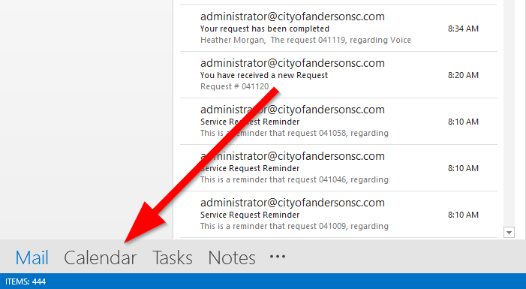

While in Calendar, select ‘New Meeting‘ at the top left-hand corner.

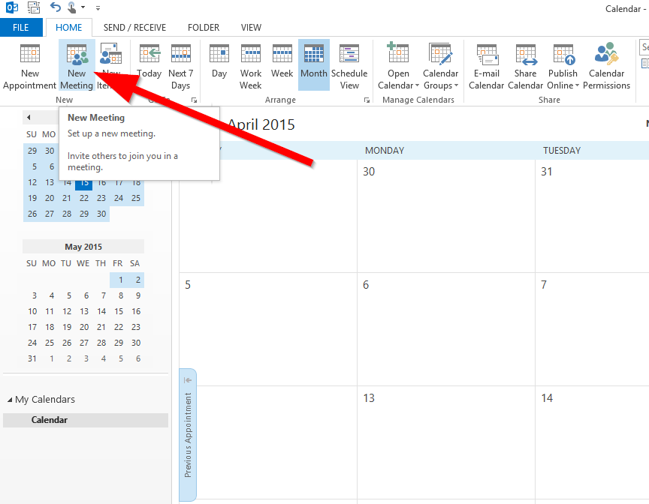

The New Meeting window will appear which allows you to select the date, time and room you wish to schedule a meeting for.

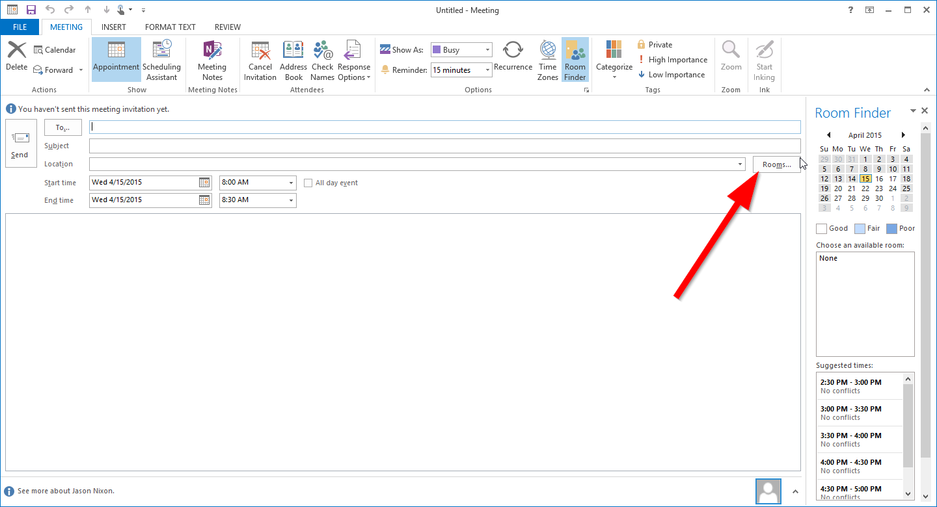

Once the Rooms button is selected, the Select Rooms window will appear.

Double-click the room you wish to schedule a block of time for which will populate the To: field. 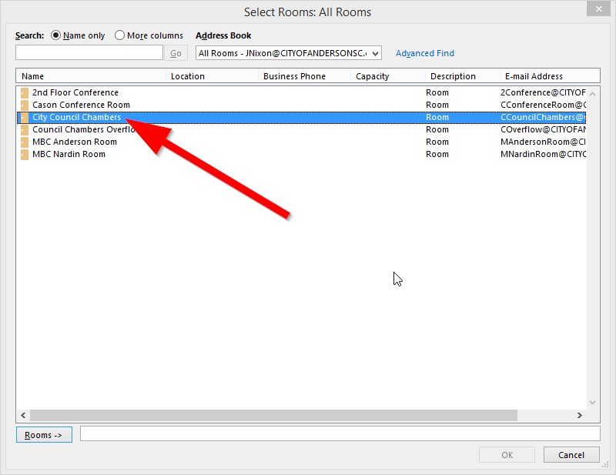

Select the OK button to confirm the selection.

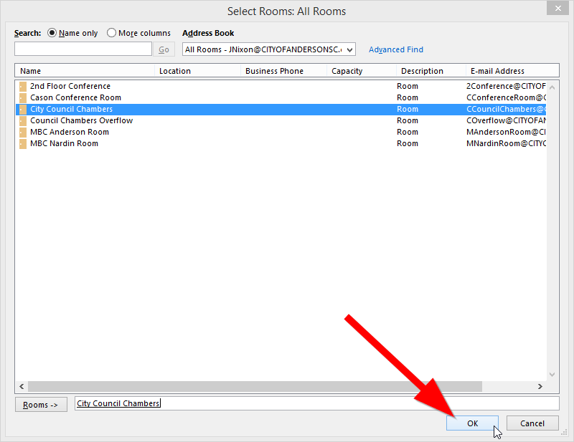

The conference / meeting location you selected within the Select Rooms window, will be displayed in the New Meeting window next to the To: field.

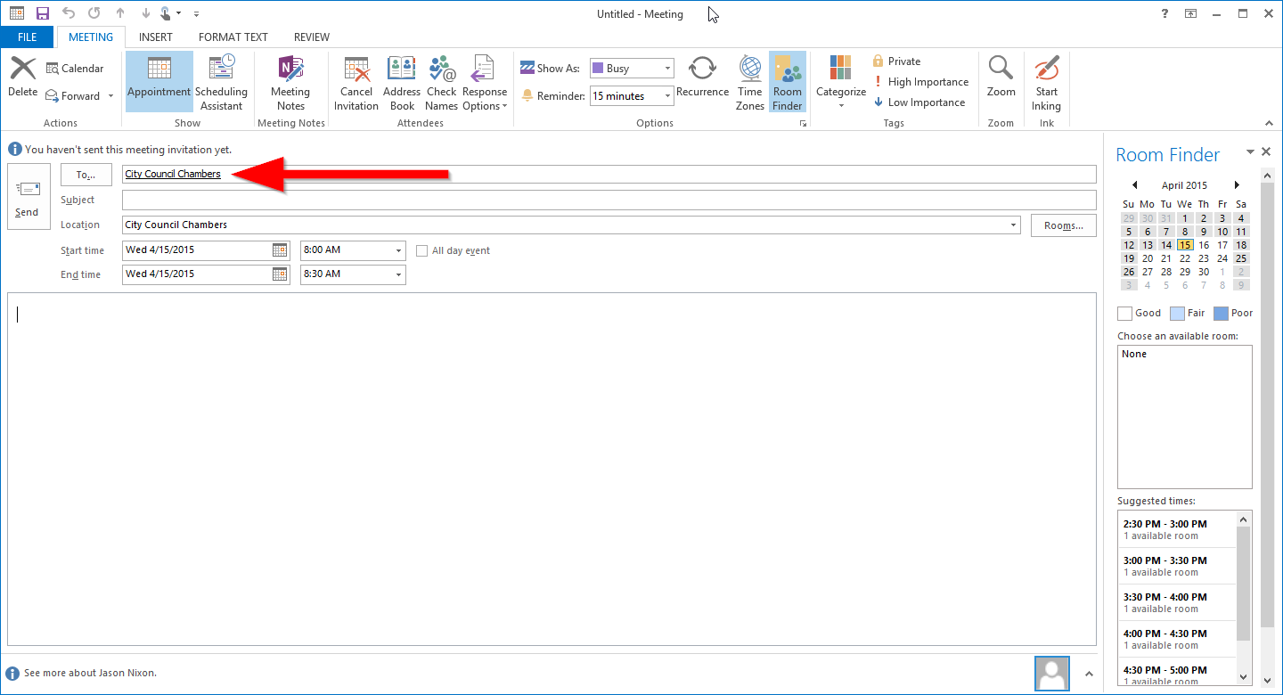

Add a subject to the Subject line and select a beginning and end date / time.

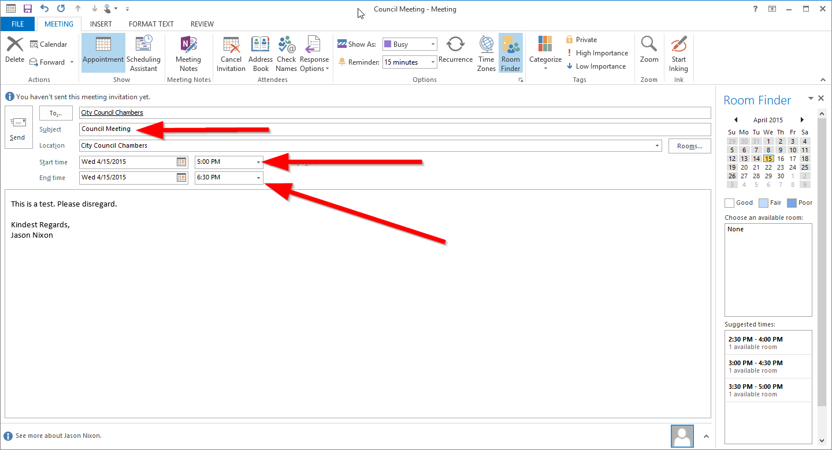

A list box of suggested, available times will help ensure you are not creating a scheduling conflict.

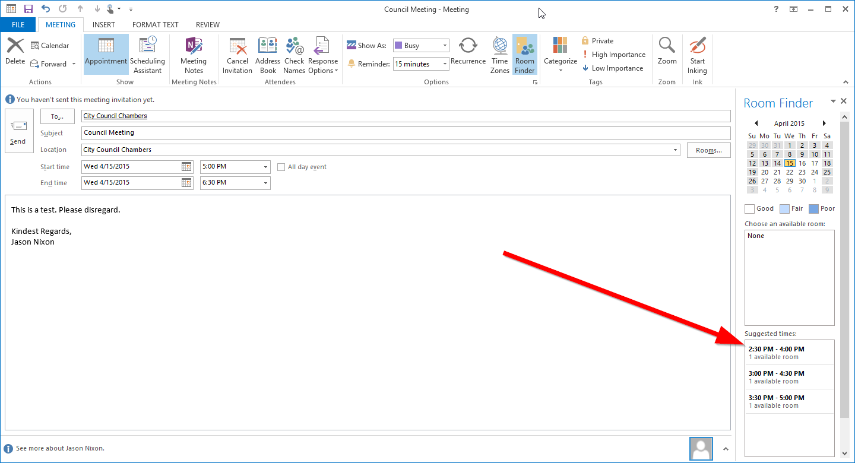

Once you have selected the date, time and added a subject with an optional message in the body of the email, click the Send button to confirm the meeting. An email will be generating and sent to all those who are linked to the chosen conference room.

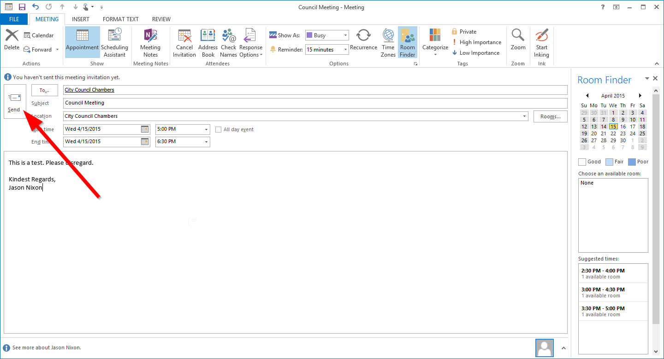

Your selected conference room is now reserved.

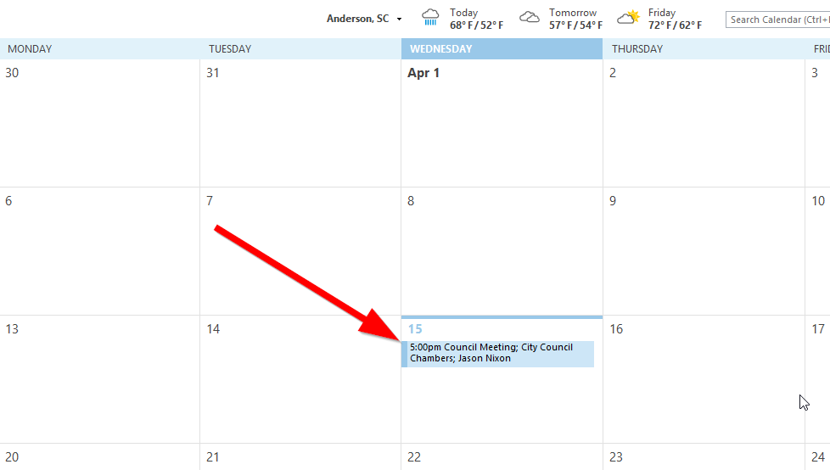

**RESERVATION DECLINED**

If for some reason there is a scheduling conflict or your reservation is declined, you will receive and email similar to the one below. It will display what has happened, why and by whom, if applicable.

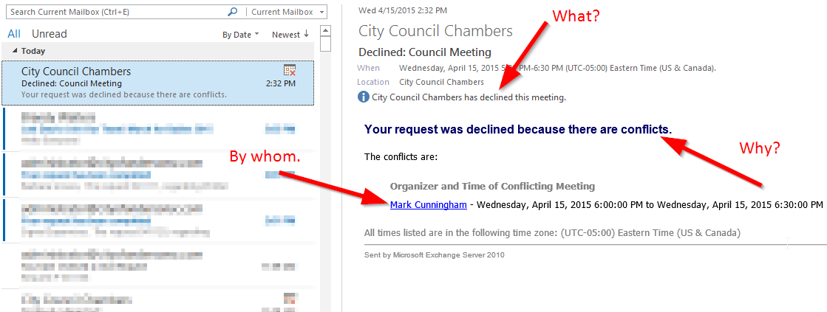

VIEW EXISTING RESERVATIONS

If you would like to view existing reservations prior to making one, follow the steps below.

Within the Calendar window in Outlook, select Open Calendar.

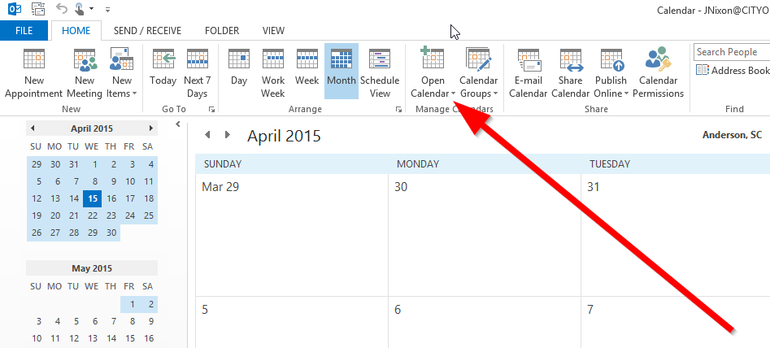

Now select From Room List as shown below.

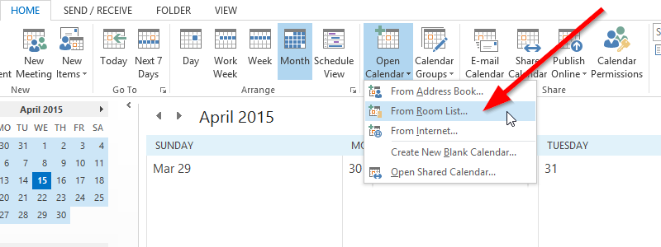

From the Select Rooms window, click the room you wish to view reservations for.

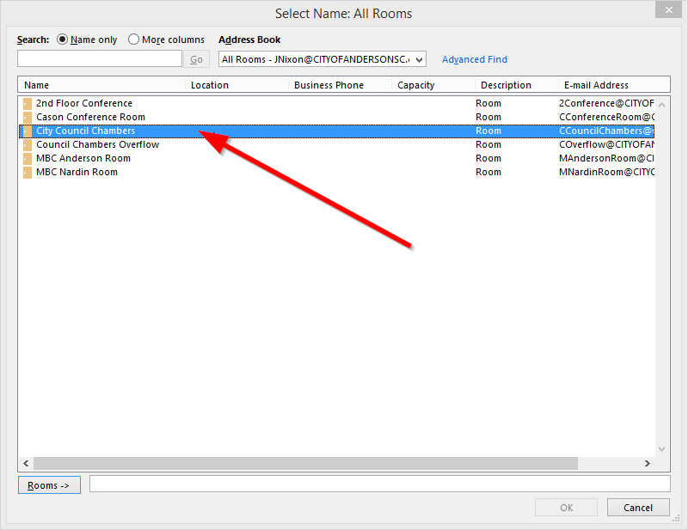

Once selected the room name will appear in the Rooms selection box then you can select the OK button.

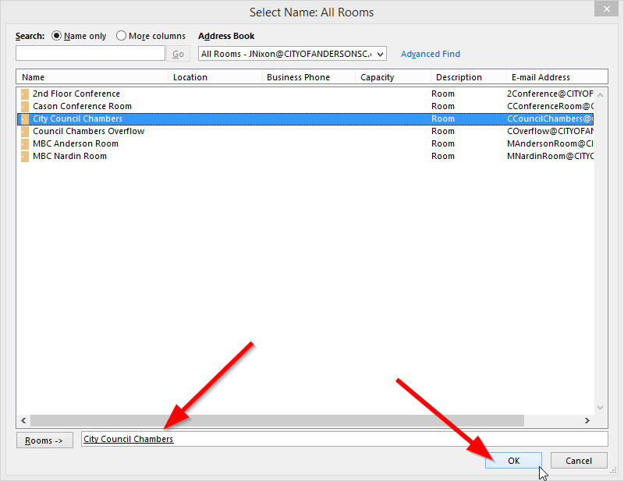

Now the Room calendar you selected above will be displayed next to your own calendar as shown below.

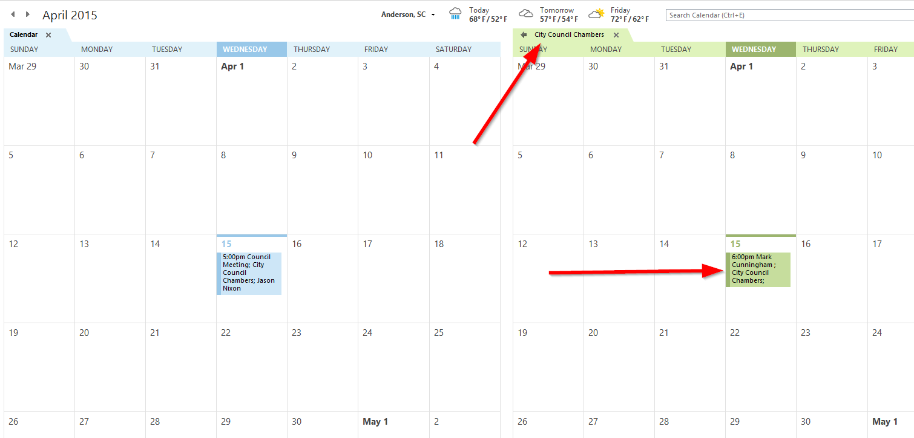

You can select a day to schedule a meeting within the conference room by selecting the New Meeting button at the top left-hand corner of the Calendar window. Select New Meeting with everyone as shown below.

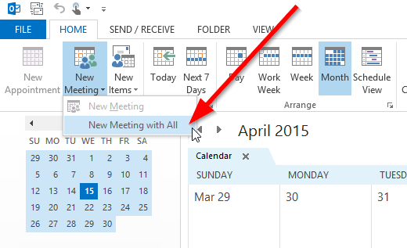

Now create your new room reservation as noted in the instructions above.