How to Sync Shared folders:

1: Login to portal.office.com

2: Navigate to Onedrive within portal.

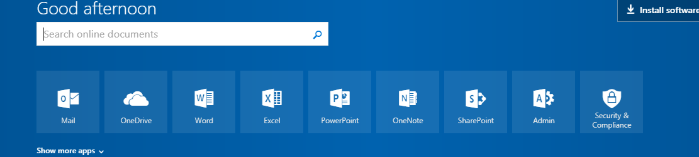

3: Select “Shared with me” on the left of the screen.

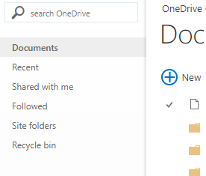

4:Click to open the folder you want to sync down to the computer. 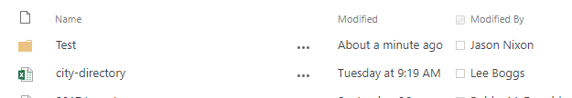

5: Click Sync icon.

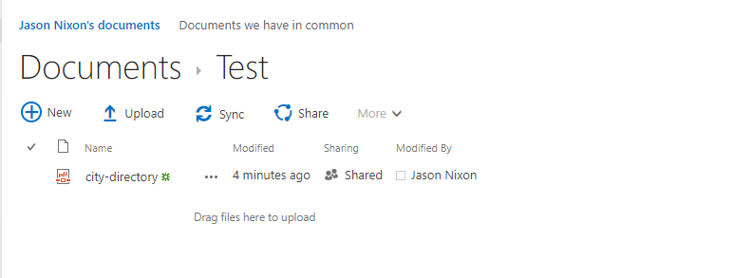

6: Select Open Microsoft OneDrive.

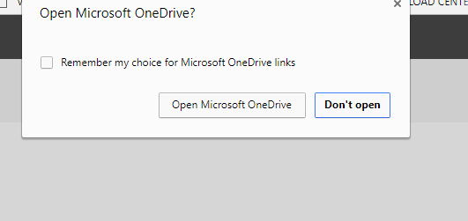

7: Open File Explorer.



8: You will notice a new option in your favorites on the left side. This will be the folder with your shared documents.

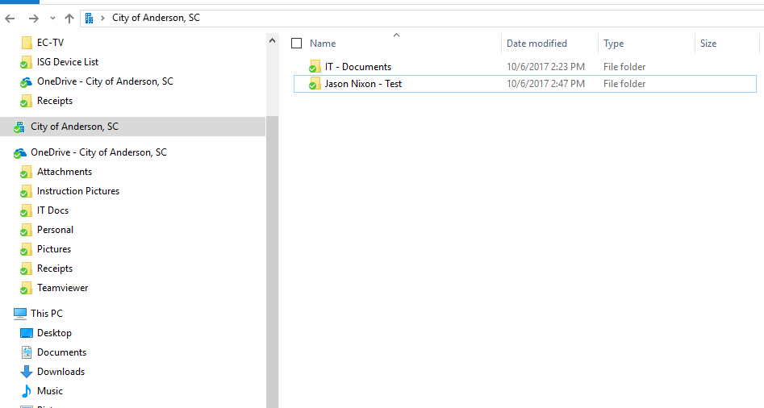

**How to Share files from your computer.**

1: Open File Explorer.

2: Navigate to the file you want to share.

3: Right click on the file and select Share with the blue cloud beside it.

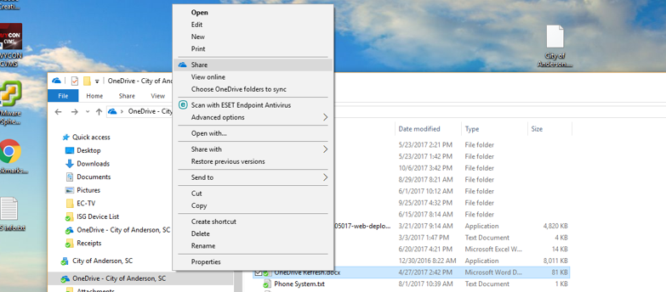

4: Share OneDrive screen will appear. There are 2 ways to share a document.

Option 1: To share a file with a City employee, type the employee name and Click Send. This will send the person an email to notify them they have a file that has been shared. You can change the access to the document by selecting the drop down. You can let the user view or edit document.

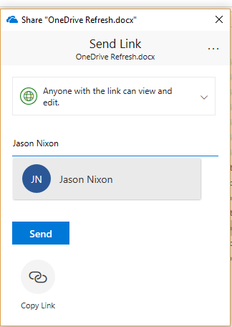

Option 2: Select Copy Link icon on the bottom. Click the copy button and email the link to the person you want to share the file with.



