One Drive Setup:

1. Open up a web browser and navigate to [www.portal.office.com](http://www.portal.office.com).
2. Login using City email address and email password. Verify the page says Work or School.

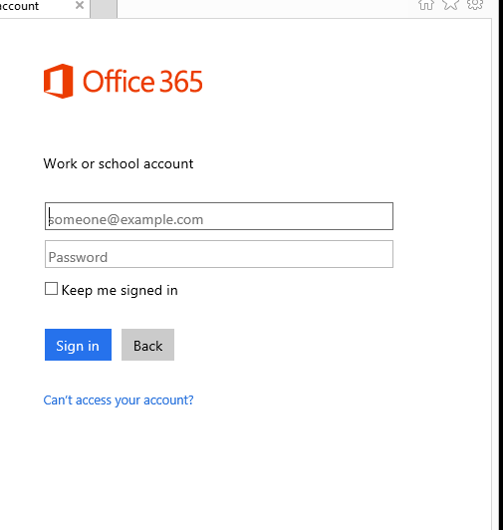

1. Once Logged in, click the Install Software Icon.

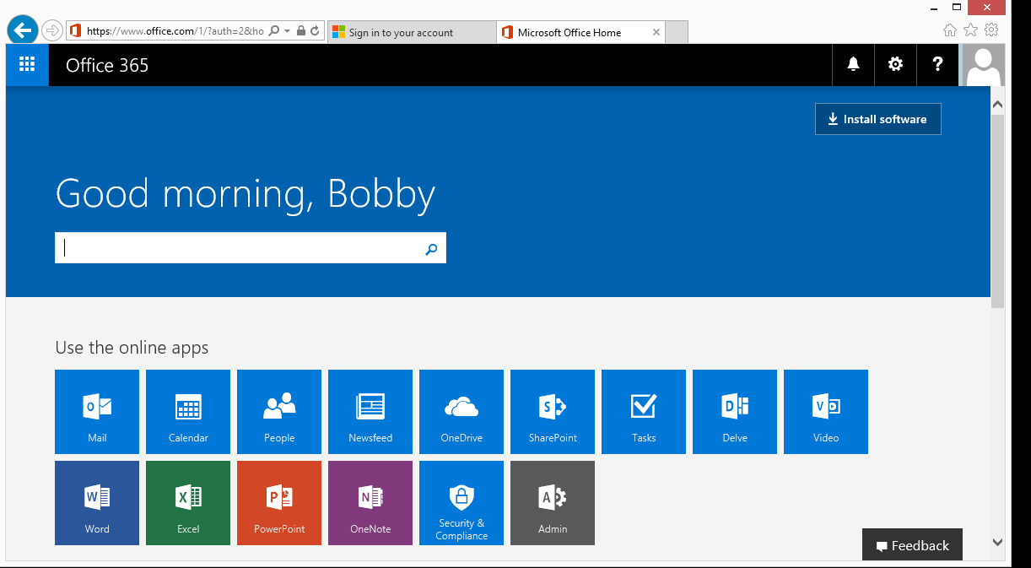

1. On the left side of the screen and click “OneDrive”

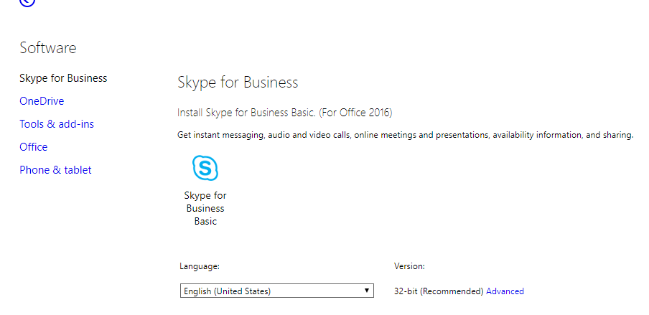

1. One the next screen click the Install button.

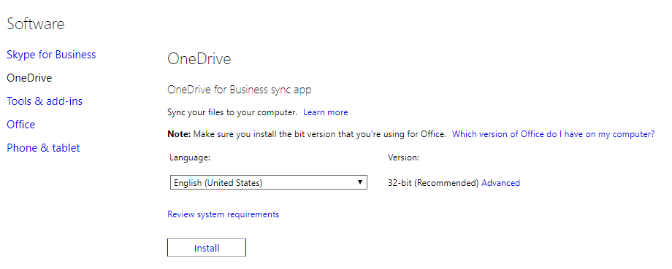

1. If you are using Internet Explorer or Google Chrome to access the Office 365 portal, the download will be at the bottom of the screen. In Fire fox the download will be in the top right screen with a blue arrow.



1. Click Run and OneDrive will start installing.

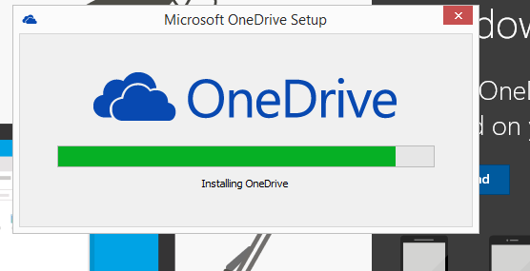

1. Once OneDrive has installed, you will need to enter your credentials for account. When you get the screen to enter your password, make sure to select Work or School.

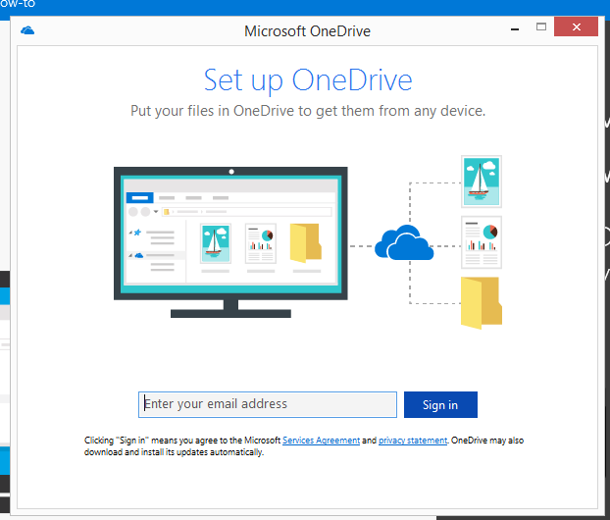

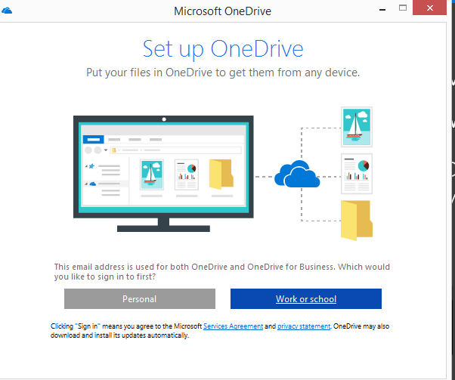

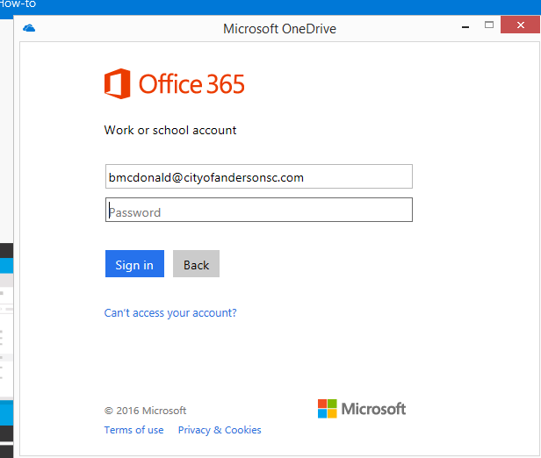

1. You can now navigate to File Explorer and view City of Anderson OneDrive.

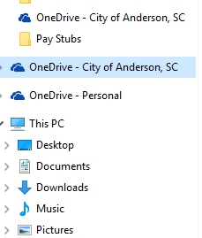

1. Highlight the files you want to move to OneDrive and drag the files to the OneDrive- City of Anderson, SC folder.
2. The files will then start to upload to the Cloud automatically.
3. Once the files have been uploaded a green check mark will be beside the folder/file.
4. To Share the files to other users, click the three circles to the right of the file name. A drop down box will appear and click Share.

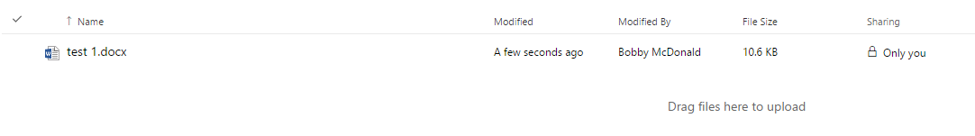

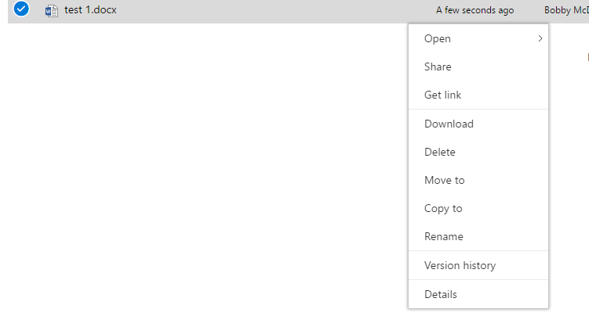

1. Type in the name of the person you want to share the file with and click share. Make sure to allow permission to either edit of too view.

