Refresh Internet Explorer:

1: go to Internet Explorer.

2: Click on the gear in the top right corner of the screen.

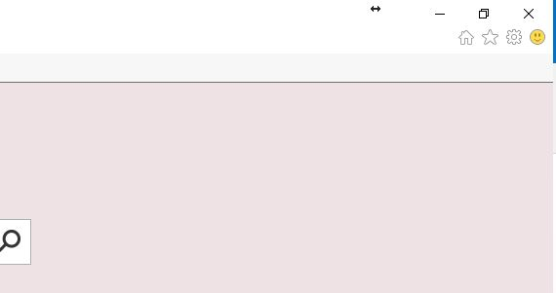

3: A drop down box will be displayed, Click Internet Options at the bottom.

4: Under Browsing History, Click Delete.

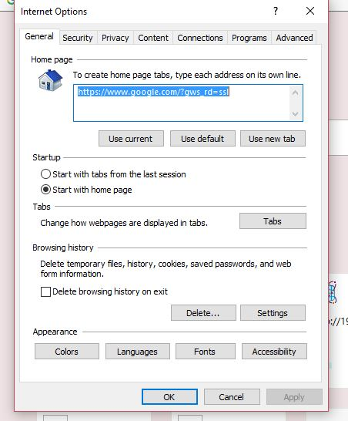

5: Make sure you check the boxes as shown and then click delete.

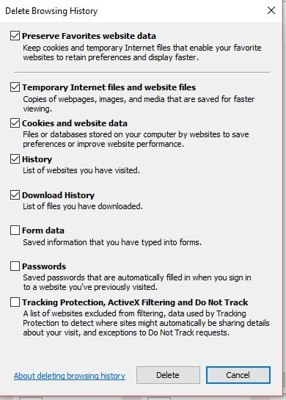

6: Click Ok on the next screen.



7: Close Browser and try to access CJIS File Sharing.