How to add email address to safe senders in Outlook

1: Go to Outlook and click Home Tab at the top.

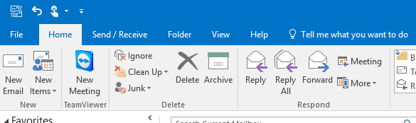

2: Click the Junk Icon. Then select Junk email options.

3: Select Safe Senders tab at the top. Then click add.

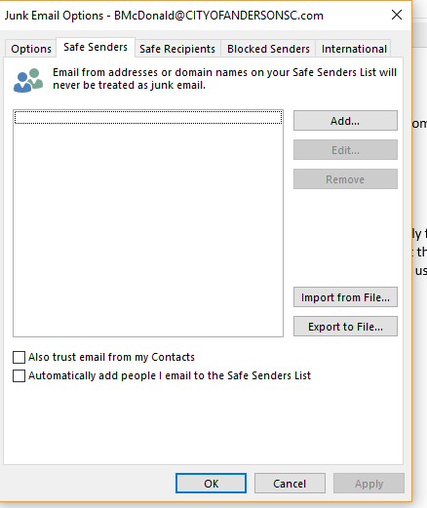

4: Type in [scanner@cityofandersonsc.com](mailto:scanner@cityofandersonsc.com) and click ok.

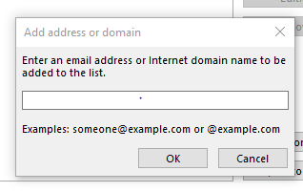

5: Click Apply and then ok on the Junk Email Options dialogue box. The emails will now go to inbox.